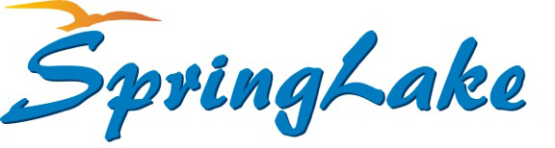
Board of Supervisors
Meeting Agenda
March 9, 2022
10:00 a.m. District Office

- Call to order and pledge Chairman McKenna

- Upcoming Meetings/Events/Correspondence Chairman McKenna
  - March 9, 2022, Annual St Pats Luncheon, noon, Gator Shack

- Comcast Presentation Derek Cooper
Jen Boyett

- Public Hearing – Utility Rates and Fees Dyana Stewart FRWA

- Adjourn for 10-minute break

- Approval of Minutes, February 9, 2022 Chairman McKenna

- Approval of February 2022 Financials Chairman McKenna

- Treasurer Diane Angell
  - Update
  - Resolution 2022-02 Utility Rates and Fees
  - Resolution 2022-03 Utility Policies and Procedures

- Manager Joe DeCerbo
  - Updates
  - Pickleball Courts

- Attorney William Nielander

- Succession Planning Bill Lawens

- Supervisor Requests

- Public Comments

- Next Meeting

- April 13, 2022 @ 10:00 a.m.

- Motion to Adjourn Tim McKenna

